**Large Italian Giltwood Antique Mirror**

**Price: $5000**

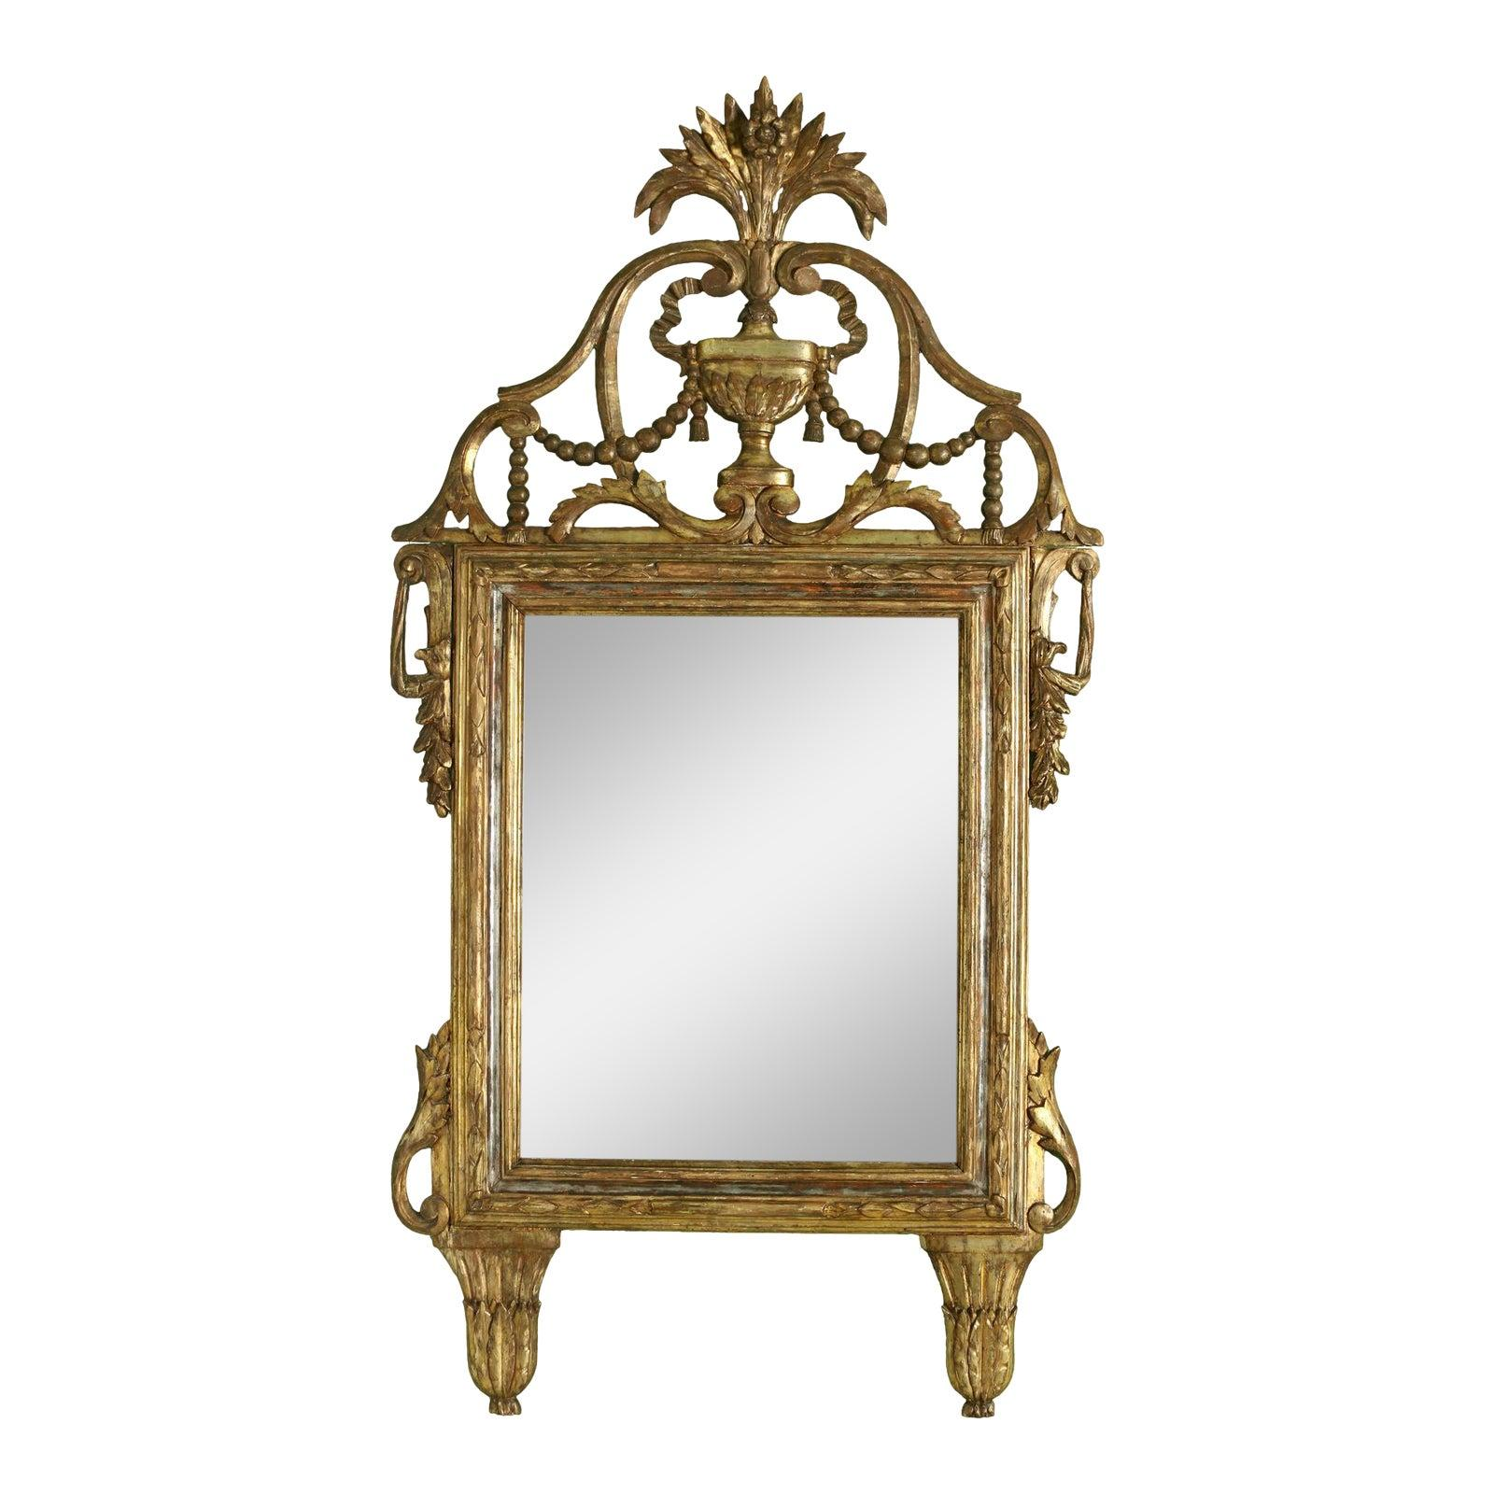

* CATEGORIES

Drawing/Living room mirrors

* MATERIALS

Wooden framed

* SHAPE

Rectangle

* BRAND

Viglacera